TESTING

# Introduction

**Testing** is a process of evaluation of the system to find errors. Testing performed successfully will eliminate all the faults from the system.

# Principles of testing

* Test must be planned before its implementation.
* Testing should be done by the third party software.
* The test needs to fulfill the customer requirements.
* 80/20 rule is followed which states that 80% of the errors arrives from 20% of the work.
* Small parts should be tested first and can be extended to large.

# Black box Testing

It is a software testing method, though usually functional where the internal part (design, structure, implementation) being tested is not known to the tester.

## Advantages of black box testing

* Upon completion of the functional specifications, each test can be designed.
* Could be non-technical test tester.
* Detailed functional knowledge of the system is not required by the tester.

## Disadvantages of the black box testing

* If test cases are not developed on the basis of the specification, then tricky inputs would be hard to identify.
* Along with the test cases, design is challenging without clear functional specifications.

|  |  |  |  |  |  |  |  |
| --- | --- | --- | --- | --- | --- | --- | --- |
| **Test** | **Testcase** | **Expected result** | | **Actual result** | **Pass/Fail** | **Action** | **Conclusion** |
| **case** |  |  |  |  |  |  |  |
| **No.** |  |  |  |  |  |  |  |
|  |  |  |  |  |  |  |  |
| **1** | Login | By | entering username | System | Pass | No action | Pass |
|  |  | and | password, user is | accessed |  |  |  |
|  |  | able access the system | |  |  |  |  |
|  |  |  |  |  |  |  |  |

|  |  |  |  |  |  |  |  |
| --- | --- | --- | --- | --- | --- | --- | --- |
| **Test** | **Testcase** | **Expected result** | **Actual result** | | **Pass/Fail** | **Action** | **Conclusion** |
| **case** |  |  |  |  |  |  |  |
| **No.** |  |  |  |  |  |  |  |
|  |  |  |  |  |  |  |  |
| 2 | Register | User can redirect to login | Login | form | Pass | No action | Pass |
|  |  | after filling details on | viewed |  |  |  |  |
|  |  | register page |  |  |  |  |  |
|  |  |  |  |  |  |  |  |

|  |  |  |  |  |  |  |  |
| --- | --- | --- | --- | --- | --- | --- | --- |
| **Test** | **Testcase** | **Expected result** |  | **Actual result** | **Pass/Fail** | **Action** | **Conclusion** |
| **case** |  |  |  |  |  |  |  |
| **No.** |  |  |  |  |  |  |  |
|  |  |  |  |  |  |  |  |
| 3 | Add Category | User can add new  Category. |  | Successfull | Pass | No action | Pass |
|  |  |  |  |  |  |  |  |
|  |  |  |  |  |  |  |  |

|  |  |  |  |  |  |  |  |
| --- | --- | --- | --- | --- | --- | --- | --- |
| **Test** | **Testcase** | **Expected result** | **Actual result** | | **Pass/Fail** | **Action** | **Conclusion** |
| **case** |  |  |  |  |  |  |  |
| **No.** |  |  |  |  |  |  |  |
|  |  |  |  |  |  |  |  |
| 4 | Add | New Supplier will be added in | Supplier |  | Pass | No action | Pass |
|  | supplier | database | added | in |  |  |  |
|  |  |  | database |  |  |  |  |
|  |  |  |  |  |  |  |  |

|  |  |  |  |  |  |  |  |
| --- | --- | --- | --- | --- | --- | --- | --- |
| **Test** | **Testcase** | **Expected result** | **Actual result** | | **Pass/Fail** | **Action** | **Conclusion** |
| **case** |  |  |  |  |  |  |  |
| **No.** |  |  |  |  |  |  |  |
|  |  |  |  |  |  |  |  |
| 5 | Edit | Supplier should be Edited | Supplier |  | Pass | No action | Pass |
|  | Supplier | in database | edited | in |  |  |  |
|  |  |  | database |  |  |  |  |
|  |  |  |  |  |  |  |  |

|  |  |  |  |  |  |  |  |  |
| --- | --- | --- | --- | --- | --- | --- | --- | --- |
| **Test** | **Testcase** | **Expected result** | |  | **Actual result** | **Pass/Fail** | **Action** | **Conclusion** |
| **case** |  |  |  |  |  |  |  |  |
| **No.** |  |  |  |  |  |  |  |  |
|  |  |  |  |  |  |  |  |  |
| 6 | Delete | Supplier | should | be | Supplier | Pass | No action | Pass |
|  | Supplier | deleted from database. | |  | deleted from |  |  |  |
|  |  |  |  |  | database |  |  |  |
|  |  |  |  |  |  |  |  |  |

|  |  |  |  |  |  |  |  |
| --- | --- | --- | --- | --- | --- | --- | --- |
| **Test** | **Testcase** | **Expected result** |  | **Actual result** | **Pass/Fail** | **Action** | **Conclusion** |
| **case** |  |  |  |  |  |  |  |
| **No.** |  |  |  |  |  |  |  |
|  |  |  |  |  |  |  |  |
| 7 | Add | Customers should | be | Display error | Fail | Fix error | Fail |
|  | Customer | added to database |  | message |  | message |  |
|  |  |  |  |  |  |  |  |

|  |  |  |  |  |  |  |  |
| --- | --- | --- | --- | --- | --- | --- | --- |
| **Test** | **Testcase** | **Expected result** | **Actual result** | | **Pass/Fail** | **Action** | **Conclusion** |
| **case** |  |  |  |  |  |  |  |
| **No.** |  |  |  |  |  |  |  |
|  |  |  |  |  |  |  |  |
| 8 | Edit | Customer should be Edited | Customer |  | Pass | No action | Pass |
|  | Customer | in database | edited | in |  |  |  |
|  |  |  | database |  |  |  |  |
|  |  |  |  |  |  |  |  |

|  |  |  |  |  |  |  |  |  |
| --- | --- | --- | --- | --- | --- | --- | --- | --- |
| **Test** | **Testcase** | **Expected result** | |  | **Actual result** | **Pass/Fail** | **Action** | **Conclusion** |
| **case** |  |  |  |  |  |  |  |  |
| **No.** |  |  |  |  |  |  |  |  |
|  |  |  |  |  |  |  |  |  |
| 9 | Delete | Customer | should | be | Customer | Pass | No action | Pass |
|  | Customer | deleted from database. | |  | deleted from |  |  |  |
|  |  |  |  |  | database |  |  |  |
|  |  |  |  |  |  |  |  |  |

|  |  |  |  |  |  |  |  |
| --- | --- | --- | --- | --- | --- | --- | --- |
| **Test** | **Testcase** | **Expected result** |  | **Actual result** | **Pass/Fail** | **Action** | **Conclusion** |
| **case** |  |  |  |  |  |  |  |
| **No.** |  |  |  |  |  |  |  |
|  |  |  |  |  |  |  |  |
| 10 | Edit customer  address | Address should | be | Display error | Fail | Fix error | Fail |
|  |  | added to database |  | message |  | message |  |
|  |  |  |  |  |  |  |  |

|  |  |  |  |  |  |  |  |  |
| --- | --- | --- | --- | --- | --- | --- | --- | --- |
| **Test** | **Testcase** | **Expected result** | |  | **Actual result** | **Pass/Fail** | **Action** | **Conclusion** |
| **case** |  |  |  |  |  |  |  |  |
| **No.** |  |  |  |  |  |  |  |  |
|  |  |  |  |  |  |  |  |  |
| 11 | Add | Product | should | be | Product | Pass | No action | Pass |
|  | New Product | added to database. | |  | added to |  |  |  |
|  |  |  |  |  | database |  |  |  |
|  |  |  |  |  |  |  |  |  |

|  |  |  |  |  |  |  |  |  |
| --- | --- | --- | --- | --- | --- | --- | --- | --- |
| **Test** | **Testcase** | **Expected result** | |  | **Actual result** | **Pass/Fail** | **Action** | **Conclusion** |
| **case** |  |  |  |  |  |  |  |  |
| **No.** |  |  |  |  |  |  |  |  |
|  |  |  |  |  |  |  |  |  |
| 12 | Delete | Product | should | be | Product | Pass | No action | Pass |
|  | Product | deleted from database. | |  | deleted from |  |  |  |
|  |  |  |  |  | database |  |  |  |
|  |  |  |  |  |  |  |  |  |

|  |  |  |  |  |  |  |  |
| --- | --- | --- | --- | --- | --- | --- | --- |
| **Test** | **Testcase** | **Expected result** | **Actual result** | | **Pass/Fail** | **Action** | **Conclusion** |
| **case** |  |  |  |  |  |  |  |
| **No.** |  |  |  |  |  |  |  |
|  |  |  |  |  |  |  |  |
| 13 | Edit | Product should be Edited | Product |  | Pass | No action | Pass |
|  | Product | in database | Edited | in |  |  |  |
|  |  |  | database |  |  |  |  |
|  |  |  |  |  |  |  |  |

|  |  |  |  |  |  |  |  |
| --- | --- | --- | --- | --- | --- | --- | --- |
| **Test** | **Testcase** | **Expected result** |  | **Actual result** | **Pass/Fail** | **Action** | **Conclusion** |
| **case** |  |  |  |  |  |  |  |
| **No.** |  |  |  |  |  |  |  |
|  |  |  |  |  |  |  |  |
| 14 | Add | Images should | be | Display error | Fail | Fix error | Fail |
|  | Product image | added to database |  | message |  | message |  |
|  |  |  |  |  |  |  |  |

|  |  |  |  |  |  |  |  |
| --- | --- | --- | --- | --- | --- | --- | --- |
| **Test** | **Testcase** | **Expected result** | **Actual result** | | **Pass/Fail** | **Action** | **Conclusion** |
| **case** |  |  |  |  |  |  |  |
| **No.** |  |  |  |  |  |  |  |
|  |  |  |  |  |  |  |  |
| 15 | Add | Purchases will be added in | Purchases |  | Pass | No action | Pass |
|  | New purchases | database | added | in |  |  |  |
|  |  |  | database |  |  |  |  |
|  |  |  |  |  |  |  |  |

|  |  |  |  |  |  |  |  |
| --- | --- | --- | --- | --- | --- | --- | --- |
| **Test** | **Testcase** | **Expected result** | **Actual result** | | **Pass/Fail** | **Action** | **Conclusion** |
| **case** |  |  |  |  |  |  |  |
| **No.** |  |  |  |  |  |  |  |
|  |  |  |  |  |  |  |  |
| 16 | Edit | Purchases should be Edited | Purchases |  | Pass | No action | Pass |
|  | Purchases | in database | edited | in |  |  |  |
|  |  |  | database |  |  |  |  |
|  |  |  |  |  |  |  |  |

|  |  |  |  |  |  |  |  |  |
| --- | --- | --- | --- | --- | --- | --- | --- | --- |
| **Test** | **Testcase** | **Expected result** | |  | **Actual result** | **Pass/Fail** | **Action** | **Conclusion** |
| **case** |  |  |  |  |  |  |  |  |
| **No.** |  |  |  |  |  |  |  |  |
|  |  |  |  |  |  |  |  |  |
| 17 | Delete | Purchases | should | be | Purchases | Pass | No action | Pass |
|  | Purchases | deleted from database. | |  | deleted from |  |  |  |
|  |  |  |  |  | Database |  |  |  |
|  |  |  |  |  |  |  |  |  |

|  |  |  |  |  |  |  |  |
| --- | --- | --- | --- | --- | --- | --- | --- |
| **Test** | **Testcase** | **Expected result** | **Actual result** | | **Pass/Fail** | **Action** | **Conclusion** |
| **case** |  |  |  |  |  |  |  |
| **No.** |  |  |  |  |  |  |  |
|  |  |  |  |  |  |  |  |
| 18 | Add | Sales will be added in | Sales |  | Pass | No action | Pass |
|  | Sales | database | added | in |  |  |  |
|  |  |  | database |  |  |  |  |
|  |  |  |  |  |  |  |  |

|  |  |  |  |  |  |  |  |
| --- | --- | --- | --- | --- | --- | --- | --- |
| **Test** | **Testcase** | **Expected result** | **Actual result** | | **Pass/Fail** | **Action** | **Conclusion** |
| **case** |  |  |  |  |  |  |  |
| **No.** |  |  |  |  |  |  |  |
|  |  |  |  |  |  |  |  |
| 19 | Edit | Sales should be Edited | Sales |  | Pass | No action | Pass |
|  | Sales | in database | Edited | in |  |  |  |
|  |  |  | database |  |  |  |  |
|  |  |  |  |  |  |  |  |

|  |  |  |  |  |  |  |
| --- | --- | --- | --- | --- | --- | --- |
| **Test** | **Testcase** | **Expected result** | **Actual result** | **Pass/Fail** | **Action** | **Conclusion** |
| **case** |  |  |  |  |  |  |
| **No.** |  |  |  |  |  |  |
|  |  |  |  |  |  |  |
| 20 | Logout | User should be logout | Successfully | Pass | No action | Pass |
|  |  | from the system | logout |  |  |  |
|  |  |  |  |  |  |  |

# Unit Testing

It can be defined as the testing process of each or group of units. It is performed by software designers or software testers to validate whether each single unit is performing as per the design or not.

1. TEST Login [Passed]

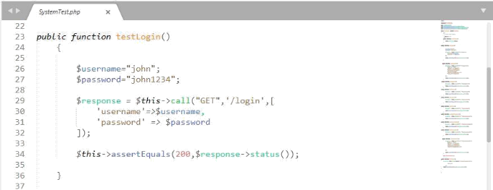

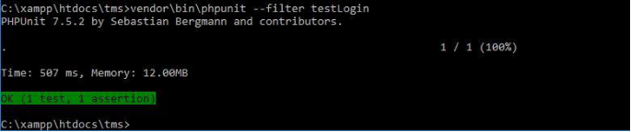

1. TEST Register [ Passed ]

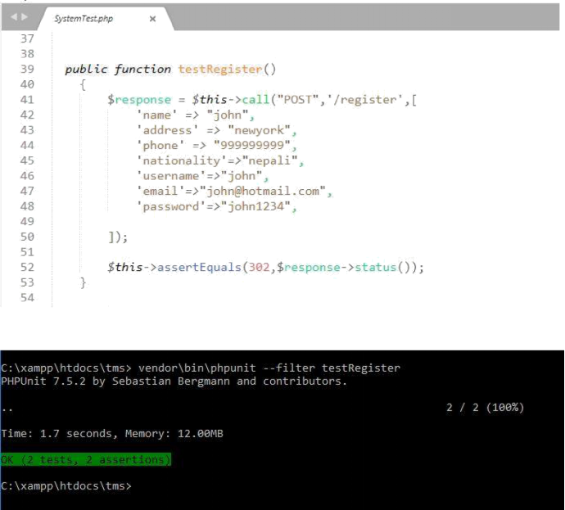

1. TEST Product [ Passed ]

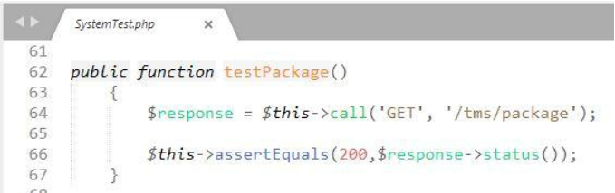

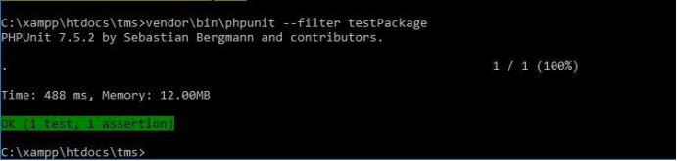

1. TEST Contact [ Passed ]

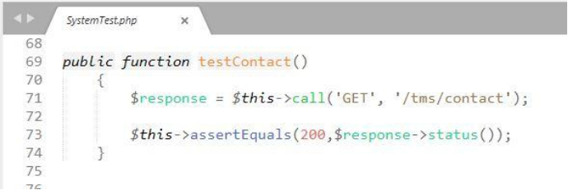

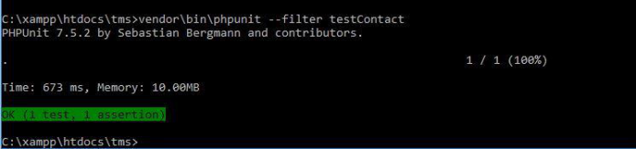

1. TEST Search [ Passed ]

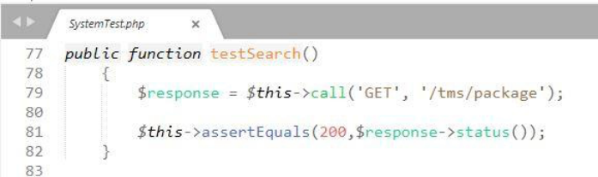

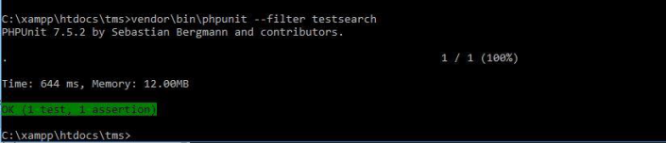

1. TEST Registered users [ Passed ]

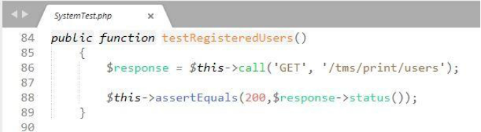

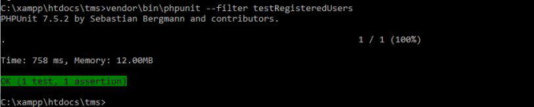

1. TEST Admin Picture [ Passed ]

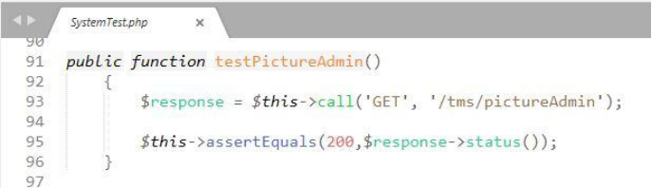

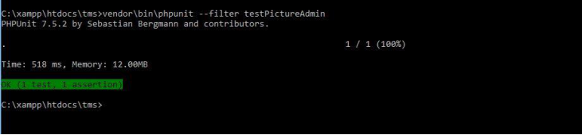

1. TEST Admin Data [ Passed ]

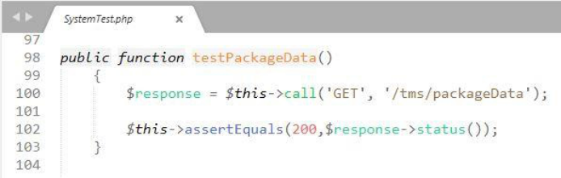

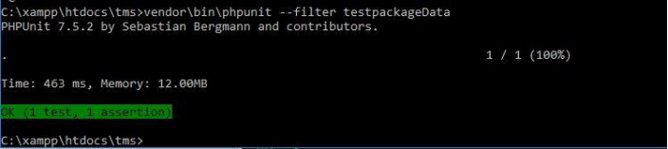

1. TEST Edit Profile [ Failed ]

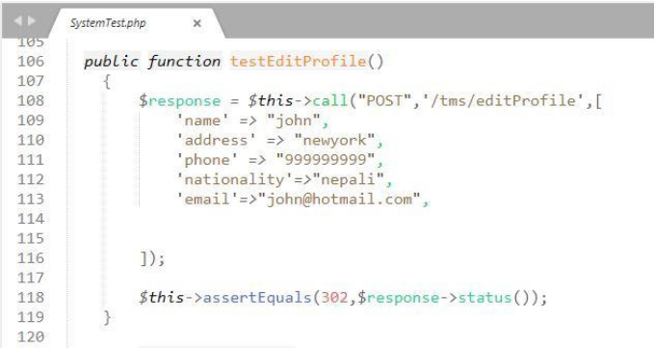

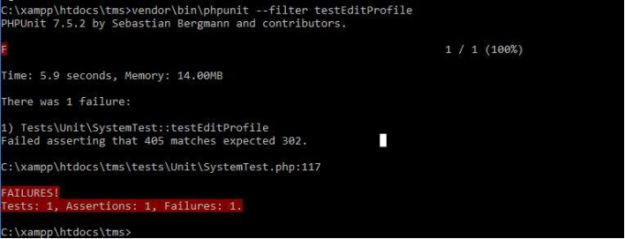

1. TEST Delete Product Data [ Passed ]

